My Plants and Beyond Software  
Requirements Specification Document

# 1 Introduction

## 1.1 Purpose

This report will outline the requirements of the Plant Care and Beyond application written by. WeeMo Inc. Ltd. LLC. The requirements will be formatted in a variety of ways to display the overall intentions of WeeMo Inc. Ltd. LLC. Requirements such as, UML diagrams, use case diagrams, functional and non-functional requirements, use case descriptions, user interfaces, hardware requirements, Table of contents, indexes, and references.

The report is intended to be a guideline for the developers of the application Plant Care and Beyond. If the members of WeeMo Inc. Ltd. LLC. were to perish and a new team would come on board, then the new team should have sufficient information to complete the project.

For investors, the guideline is intended to show the overall structure of the project and the intentions of WeeMo Inc. Ltd. LLC. has in regards to Plant Care and Beyond.

Most questions regarding Plant Care and Beyond can be resolved referencing this report, however, if any additional questions are left unanswered, the next best thing is to contact the developer team

## 1.2 Scope

The scope of Plant Care and Beyond is to empower users to take care of the plants that are most important to them. Features such as ideal growing conditions, Calendar reminders, Weather/RADAR and watering schedule are implemented to help the user maintain structure and give the plants the best growing opportunities.

## 1.3 Definitions

* **Common name/ Scientific name** - names of plants
* **Beyond** - update suggestions and comments
* **Weather radar** - It is an instrument that sends pulses of electromagnetic energy into the atmosphere to find precipitation and determine its motion and intensity.
* **Plant database** - a structured set of our plant data held in a computer.

## 1.4 References

*Sign up & log in - moqups app*. Sign Up & Log In - Moqups App. (n.d.). Retrieved October 17, 2022, from https://app.moqups.com/

“Visual Paradigm Online,” *VP Online - Online Drawing Tool*. [Online]. Available: https://online.visual-paradigm.com/app/diagrams/#diagram:proj=0&type=UseCaseDiagram&width=11&height=8.5&unit=inch. [Accessed: 17-Oct-2022].

## 

## 1.5 Overview

Organization of software requirements:

* Section 2: Software design diagrams
* User interface
* UML diagram
* Use case diagram
* Section 3:design requirements
* Functional requirement
* Non-functional requirements
* Database requirement
* Section 4: Document navigation
* Table of contents

# 2 Software Design

Users have the ability to create their own accounts and login. Once inside the app they will have the option to add or delete their desired plants. They will have a brief description of the added plants and their optimal weather conditions which will be presented daily for users.

## 2.1 Product Perspective

### 2.1.1 System Interfaces

This system is compatible with windows, mac and linux and we plan to make it available for Android/IOS to be used on phones in the future.

### 2.1.2 User Interfaces

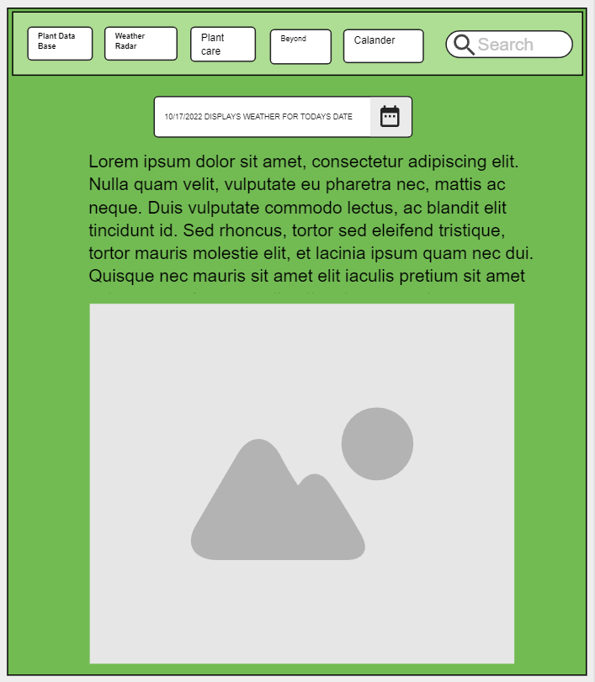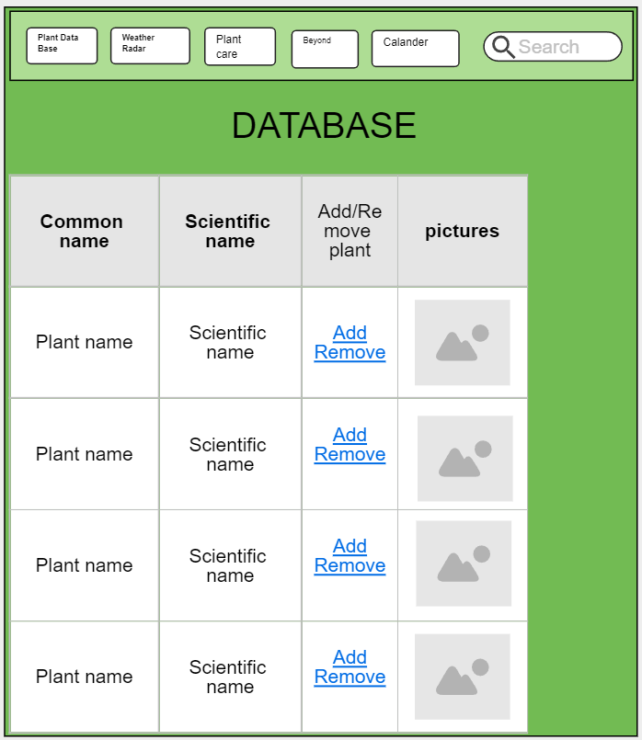

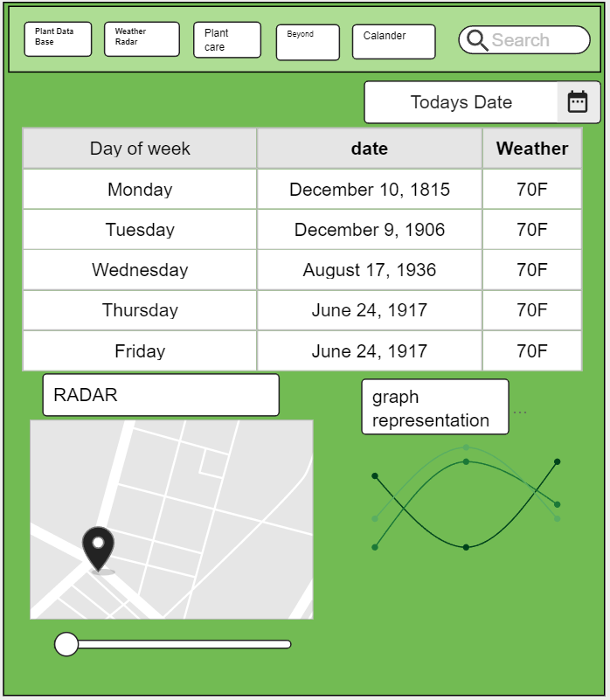

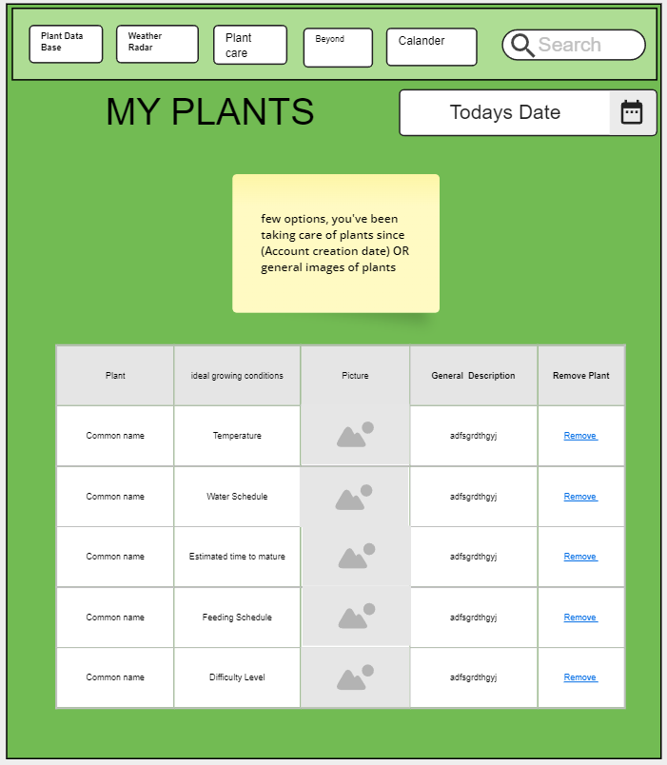

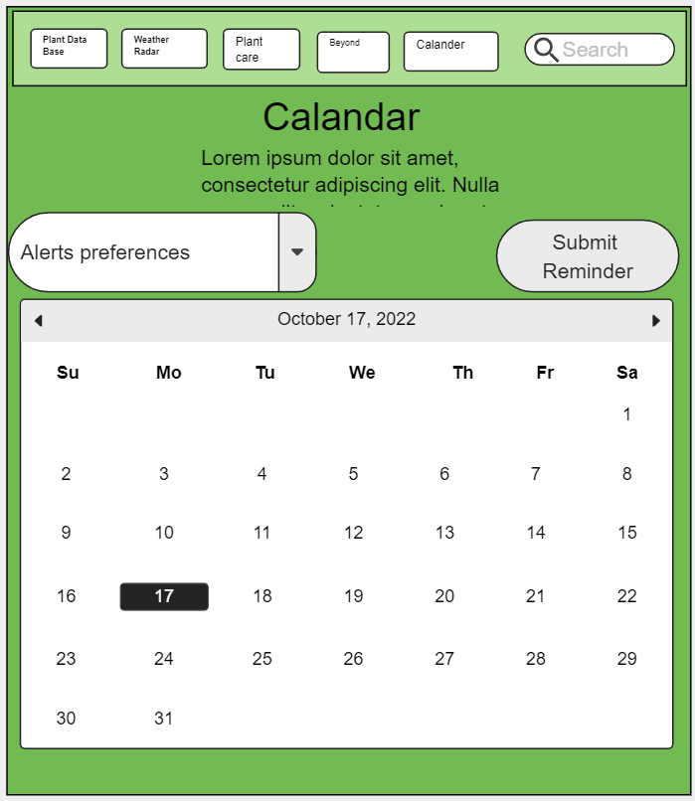

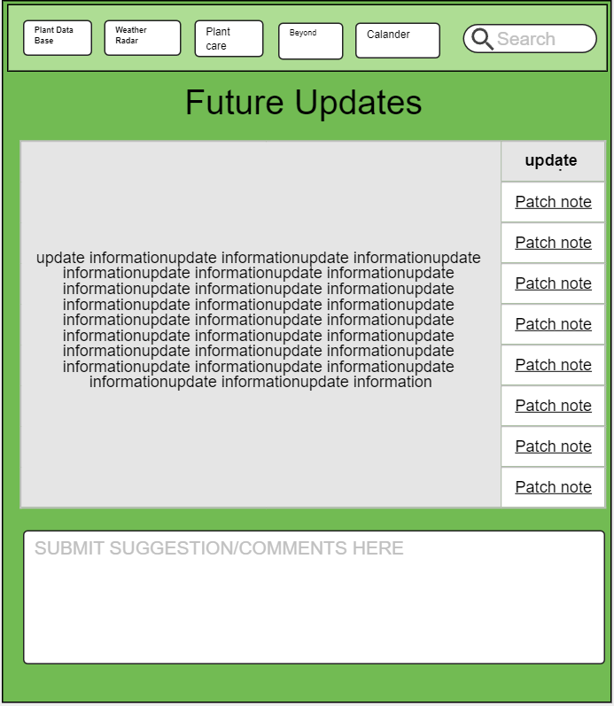

## 

## 2.2 UML Diagram

## 

## 2.3 Use Case Diagram

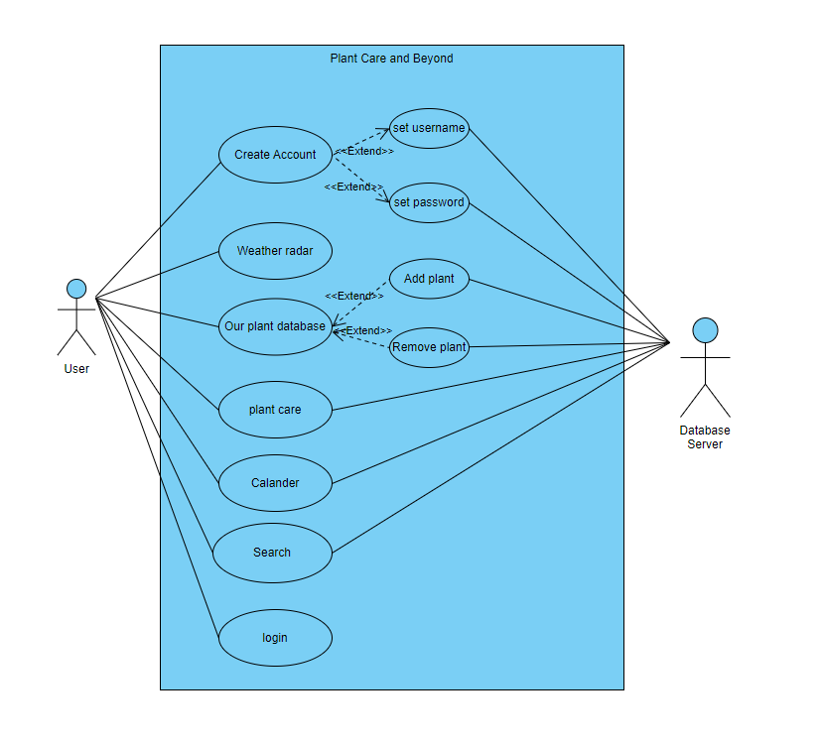

There are three layers for this use case diagram, User, Tasks, and Database Server. When users select “create Account” they will be directed to set a username and a password. Users can choose to check the weather by clicking to the “weather radar” and in “plant care” they are able to create a personal inventory where they can add or remove plants from it. They can search our database with the search button and have a calendar available to organize their plant scheduling, for example watering times.

# 

# 3 Project Requirements

## 3.1 External Interface Requirements

The following

## 3.2 Functional Requirements

### 3.2.1 Login Page

#### 3.2.1.1 Purpose

The login page exists so the user can access his/her account by entering his/her username and password. All features of this application will be inaccessible without successfully logging in using the login page.

#### 3.2.1.2 Create Account

The user shall be permitted to create an account. Upon pressing the Create User button, a pop-up display box will prompt the user with the fields described below:

1. Username (textbox, required): The user shall enter their desired username in this field. The username must be at least 5 characters in length and must contain only letters, digits, and a subset of special characters.
2. Password (password textbox, required): The user shall enter their desired password into this field. The password must be at least 5 characters in length and must contain only letters, digits, and a subset of special characters. Additionally, the password must contain AT LEAST one capital letter, one digit and one special character.
3. Re-enter Password (password textbox, required): The user shall re-enter their desired password into this field. This password must meet the same requirements as the previous password field.

The user shall be permitted to submit their account information by pressing the Create Account button. The Create Account button shall remain grayed out until all fields are filled out. Upon pressing the Create Account button, if all fields are valid the system will make an API call to the database to create a new user. If any fields are invalid, the user will be prompted with a specific error message.

#### 3.2.1.3 Login

The user shall be permitted to login from this page. The user shall enter their username and password into the dedicated fields and then press the Login button. Upon pressing the Login button, the system will make an API call to the user database.

If the information entered matches a valid user, the user will be logged in and shown the splash page. If the information entered does not match a valid user, an error message will be displayed to the user and they will not be logged in.

### 3.2.2 Splash Page

#### 3.2.2.1 Purpose

Upon accessing the splash page the user will be greeted with a friendly banner of WeeMo Inc. Ltd. LLC Plant Care and Beyond’s logo. An image of some plants will be scattered in the background to convey a peaceful response from the user. A description of what the intentions of the application is. To provide assistance to those who want Plant Care and Beyond.

### 3.2.3 Plant List

#### 3.2.3.1 Purpose

The plant list consists of A common name, scientific name, and pictures of the plant to provide the user basic information about the plant located. Upon clicking the name of the plant a general description will be provided.

### 3.2.4 Plant Data Page

#### 3.2.4.1 Purpose

The database page provides more information about the plant compared to my plants. A common name, scientific name, pictures, and the ability to add/remove plants is added to allow the user to browse the plants provided. Upon clicking the name of the plant a general description will be provided.

### 3.2.5 My Plants

#### 3.2.5.1 Purpose

My plants will be similar to a plant journal, it will have all the data from each plant, the common name, growing condition, a general description about each plant and photos. Photos can be updated, depending on the plant care and growing journey. It will show the information of indoor and outdoor plants. The description of each plant is to know how many times a plant should be water, Fertilize, placement and report to know when to pot it.

#### 3.2.5.2 Add Plant

Users have add button which will allow them to add plants to their profile

#### 3.2.5.3 Delete plant

The delete plant button will be available if the user chooses to remove a plant from their inventory.

### 3.2.6 Plant Search

#### 3.2.6.1 Purpose

The user will have the ability to search plants using a search bar that is located on the top right of every page. This feature is added to provide user accessibility

### 3.2.7 My Calendar

#### 3.2.7.1 Purpose

The calendar is a guide to tell the users when the user can water a plant. It will show what type of plant needs to be water. The user can see when a plant needs to get food and needs to be fertilized. The calendar will be good for the user to set a date and change pot size in order for the plant to be healthy and receive the best care. According to the calendar the user will have a better guide by having a planting calendar.

### 3.2.8 Weather

#### 3.2.8.1 Purpose

Upon accessing the weather section of the program users shall be able to view 5 day weather forecasts so they can prepare their plants. Radar will be available to the user to get an accurate forecast of what the weather will be for that present day. An alternative form of viewing the forecast will also be provided with a graph.Today's date will be presented to the user separately so no confusion is made with the weather forecast.

## 3.3 Non-functional Requirements

### 3.3.1 Security

To protect user data, application access will be granted once the user completes the account creation process. The system will grant access to the account when the user enters the correct username and password.

### 3.3.2 Usability

Users can easily navigate our intuitive UI, users can effortlessly determine what each feature is and what it is used for, which will allow for a smoother use of our platform.

## 3.4 Database Requirements

The database will contain two names for the same item. The scientific name or The common name will be added.

## 3.5 Hardware constraints

The hardware constraints is the user needs a mouse, keyboard, and a computer monitor/TV screen

## 3.6 Communication preferences

Weemo intends to communicate via text message, discord, groupme and other available systems.

## 3.7 Memory Constraints

The memory constraints of the system are the same constraints as the operating system the user is running.

Hardware Requirements

To interact with our application you need the following input and output devices:

* Keyboard
  + Mainly used to input text
* Computer screen (monitor)
  + Output device, this is needed to view the app with its features and interact with the UI with the help of other devices mentioned.
* Mouse
  + It is an essential device that is required to tap, scroll and select items from the UI.

**1 Introduction** **2**

1.1 Purpose 2

1.2 Scope 2

1.3 Definitions 2

1.4 References 2

1.5 Overview 3

**2 Software Design** **3**

2.1 Product Perspective 3

2.1.1 System Interfaces 3

2.1.2 User Interfaces 4

2.2 UML Diagram 9

2.3 Use Case Diagram 10

**3 Project Requirements** **11**

3.1 External Interface Requirements 12

3.2 Functional Requirements 12

3.2.1 Login Page 12

3.2.1.1 Purpose 12

3.2.1.2 Create Account 12

3.2.2 Splash Page 12

3.2.2.1 Purpose 12

3.2.3 Plant List 13

3.2.3.1 Purpose 13

3.2.4 Plant Data Page 13

3.2.4.1 Purpose 13

3.2.5 My Plants 13

3.2.5.1 Purpose 13

3.2.6 Plant Search 13

3.2.6.1 Purpose 13

3.2.7 My Calendar 13

3.2.7.1 Purpose 13

3.2.8 Weather 14

3.2.8.1 Purpose 14

3.2.9 My Plants (Plant Care and Beyond) 14

3.2.9.1 Add Plant 14

3.2.9.2 Delete plant 14

3.2.9.3 Plant Search 14

3.2.9.4 Weather Radar 14

3.2.9.5 My plants 14

3.2.9.6 Calendar 15

3.2.9.7 User Account 15

3.3 Non-functional Requirements 15

3.3.1 Security 15

3.3.2 Usability 15

3.4 Database Requirements 15

3.5 Hardware constraints 15

3.6 Communication preferences 15

3.7 memory constraints 15